
Student Management System
Software Requirements Specification
(SRS) Document

Instructor/Mentor: Prof. Bui Van Phat
Satyam Mishra
Hoàng Thị Chúc
Hoàng Gia Phi
Nguyễn Hồng Linh

02nd June, 2022

Github: https://github.com/satyamcser/StudentManagementSystemusingASP.netMVC
Or
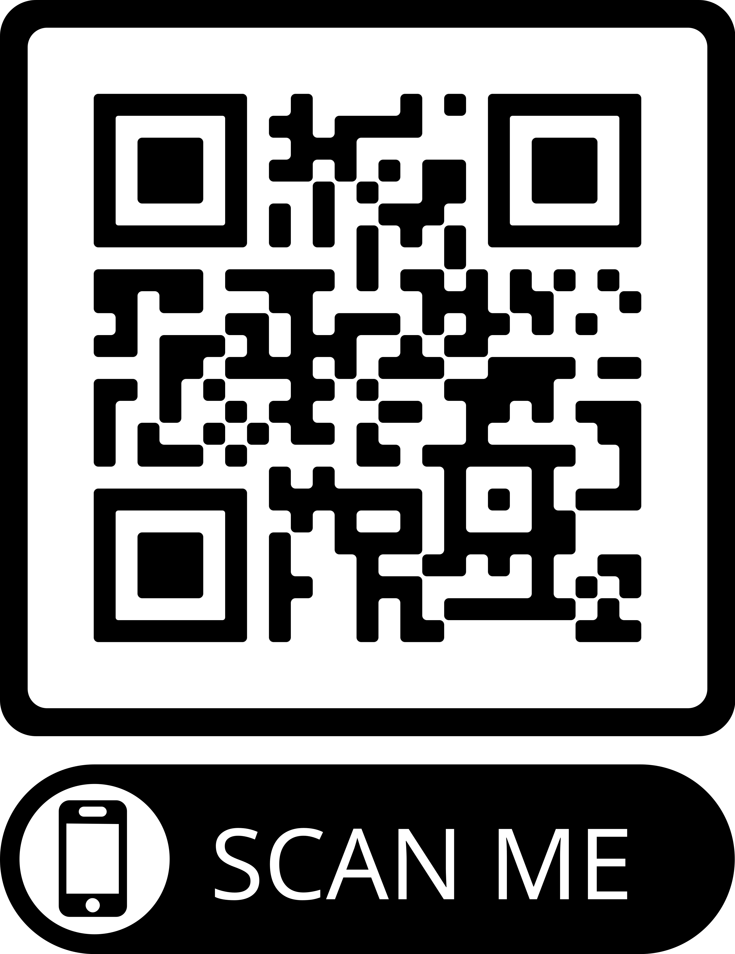

Revisions

Version | Primary Author(s) | Description of Version | Date Completed
Draft 0.1 | Satyam Mishra,  Hoang Thi Chuc | Partial draft including introductory and functional requirements sections. | 07/05/2022
Draft 0.2 | Satyam Mishra,  Hoang Thi Chuc | Pasted in references, performance requirements, and usage scenarios. Added interface requirements, UML use case diagram, non-functional requirements. | 02/06/2022

Review & Approval
Requirements Document Approval History
Approving Party | Version Approved | Signature | Date
Project Manager
Mr. Satyam Mishra

Requirements Document Review History
Reviewer | Version Reviewed | Signature | Date
Hoang Thi Chuc | Draft 0.2 | Chuc | 02/06/2022
Satyam Mishra | Draft 0.2 | Satyam | 02/06/2022
Hoang Gia Phi | Draft 0.2 | Phi | 02/06/2022
Nguyen Hong Linh | Draft 0.2 | Linh | 02/06/2022

Contents

1. Introduction 3
1.1 Purpose of this document 3
1.2 Scope of this document 3
1.3 Overview 3
1.4 Business Context 3
2. General Description 4
2.1 Product Functions 4
2.2 Similar System Information 4
2.3 User Characteristics 4
2.4 User Problem Statement 4
2.5 User Objectives 5
2.6 General Constraints 5
3. Functional Requirements 5
4. Interface Requirements 11
4.1 User Interfaces 11
4.2 Hardware Interfaces 13
4.3 Communications Interfaces 13
4.4 Software Interfaces 13
5. Performance Requirements 13
6. Other non-functional attributes 13
6.1 Reliability 13
6.2 Maintainability 13
6.3 Portability 14
6.4 Extensibility 14
6.5 Reusability 14
6.6 Application Affinity/Compatibility 14
7. Preliminary Use Case Models and Sequence Diagrams 15
7.1 Use Case Model 15
7.2 Sequence Diagrams 15
7.3 UML…………………………………………………………………………….15

1. Introduction
1.1 Purpose of this document
The purpose of this document is to provide a detailed description about the requirements needed to successfully complete the Student Management System web application for the benefit of the project management, client, and development team. Throughout this document, I will provide a general description of the project, the functional, interface, and performance requirements for the application, a list of other relevant application attributes, application usage scenarios, and use case diagrams, as well as ER Diagram.
1.2 Scope of this document
This requirements effort intends to define the requirements for the Student Management System web application. The requirements elicitation team includes Satyam Mishra, Hoang Thi Chuc, Gia Phi and Hong Thi Linh. The team spent the period between March 2022 and June 2022 identifying and documenting functional, interface, performance, and other requirements for the Student Management System. Actual time spent on requirements elicitation during that period will be considerably less than the total 5 months scheduled, as the holidays and midterm exams are included in the same time span.
1.3 Overview
The Student Management System web application is intended to provide the user with a way to track student records, teacher records, updating-creating-deleting classes, subjects, students, teachers etc. The UI have many sections on which user can go and update the mentioned respective details. The user can add students/subjects/teachers/grades to the system, modify existing details, or select detail to remove from the system.
1.4 Business Context
The development of this software system is open source and freely available for all developers to learn from it as well as for university use purposes as well. There is no intention to commercialize it.

2. General Description
2.1 Product Functions
The Student Management System web application will allow users to access their class subjects and manage their student’s information through an easy user interface. The finished application will provide a way for users to access their class details/teacher details/grade details etc. by directly going to our Student Management System web application. One can add, remove, and edit detailed info in a list of details of either student/teacher/subject/grades etc., and share right information with other users.
2.2 Similar System Information
VNU-IS have sv.vnu.edu.vn, a similar system for students and teachers both to keep track of their needed queries. For teachers, they can get details of student’s subjects, score details etc. For students, they can know their registration details, grades and subject details.
2.3 User Characteristics
The Student Management System web application is intended to be used by admin(officials), teachers and students. A typical user should have some experience using web applications and basic operating systems. A basic knowledge of the browser or windows operating system will be sufficient to use the application effectively.
2.4 User Problem Statement
Create a college management system that must be able to keep the registration of courses, subjects, teachers and students of a university. Each college course must have multiple subjects, which in turn, contain one teacher and many students. Furthermore, the system must store the name, birthday, and salary of teachers. For the students, it must save the name, birthday, registration number and the student's grade in the subjects enrolled.
2.5 User Objectives
Create a CRUD of the entities (Courses, Subjects, Teacher, Student, Grades). List the courses and show the number of teachers, students and average of their grades for each course List the subjects and show the teacher information, number of students and their grades for each subject List the students and their respective grades of the subject
2.6 General Constraints
The application must be built using asp.net MVC. C# must be used.

3. Functional Requirements
Criticality Scale
Non-Critical | Non
Less Critical | Less
Critical | Normal
Very Critical | Very
Extremely Critical | Extreme

- The application shall maintain a list of classes for the user
  - Description - The application will store a list of subjects, classes, teachers, students, grades information for the user. This list should be accessible, editable, and persistent between application lifetimes. The associated attributes of a class are described in subsequent additional requirements.
  - Criticality - Extreme
  - Technical issues - The app must use input provided by the user and/or retrieved from an external web service to create a list of classes associated with the current user. The app should also be able to store this list in such a way that it is persistent if the application is terminated and restarted.
  - Risks - Low risk - technical implementation is relatively straightforward and there is no dependency on network or remote database connectivity.
  - Dependencies - none
- A class shall include the course title
  - Description - One attribute of a class as stored by the application will be the title of the course, for example “Web Programming II” or “Software Engineering I”.
  - Criticality - Very
  - Technical issues - This attribute must be generated from either direct user input or data retrieved from a web service or remote database.
  - Risks - Course titles can be verbose - if an attribute must be dropped because of screen real-estate concerns on the user input form for class attributes, this one will go first.
  - Dependencies - 1.
- A class shall include the course number
  - Description - Another attribute of a class is the course number for that class, for example “ITEC 320-01” or “ITEC 345-02”.
  - Criticality - Very
  - Technical issues - This attribute must be generated from either direct user input or data retrieved from a web service or remote database.
  - Risks - Low risk - implementation is simple and does not require complex interactions with other requirements
  - Dependencies - 1.
- A class shall include the location where the class meets
  - Description - Another attribute of a class is the location where the class meets, expressed in terms of a campus building and room number, like “Davis 114” or “Young 123”.
  - Criticality - Very
  - Technical issues - This attribute must be generated from either direct user input or data retrieved from a web service or remote database.
  - Risks - Low risk - implementation is simple and does not require complex interactions with other requirements
  - Dependencies - 1.
- A class shall include the name of the instructor who teaches the class
  - Description - Another attribute of a class is the name of the instructor who teaches the class, for example “Tracy Lewis-Williams” or “Edward G. Okie”.
  - Criticality - Normal
  - Technical issues - This attribute must be generated from either direct user input or data retrieved from a web service or remote database.
  - Risks - It is highly unlikely that this attribute would need to be removed, but it is lower priority than the What (3), Where (4), and When (5) attributes and could be removed if screen space is heavily constrained.
  - Dependencies - 1.
- Users shall be able to add a class to a list of classes in which they are enrolled.
  - Description - When using the application, any user should be able to add a class and its corresponding details to the list of classes the application maintains.
  - Criticality - Very
  - Technical issues - When the user presses the associated button in the application, the application should present the user with a form to allow them to add class details. After adding class details, the app should create a class instance with data fields corresponding to the user input and add the instance the list of the user’s classes.
  - Risks - Low risk - technical implementation is relatively simple and there no app-external dependencies (no network and/or remote database connectivity is required).
  - Dependencies - 1.
- Users shall be able to remove classes from the list of classes in which they are enrolled
  - Description - When using the application, any user should be able to remove a particular class from their list of classes.
  - Criticality - Very
  - Technical issues - The application should be able to remove the class from the list of classes which it maintains locally. This change should be reflected into persistent local storage, but not to any external web service or remote database.
  - Risks - Low risk - implementation is simple and does not require complex interactions with other requirements
  - Dependencies - 1.
- Users shall be able to completely reset their lists of classes
  - Description - This function would allow the user to reset their agenda to an empty state in between semesters by permanently removing all classes and all assignments associated with those classes.
  - Criticality - Less
  - Technical issues - The significant data loss associated with this function necessitates a confirmation prompt at minimum, or perhaps even a temporary undo capability, but undo capability would drastically increase the complexity of the function.
  - Risks - Since removing a single class at a time would allow the user to clear all their classes and achieve an identical state (simply in a less convenient manner) this requirement receives a lower priority and could be dropped if development time is constrained.
  - Dependencies - 1.
- The user shall be able to view their list of classes
  - Description - The application should provide a list view for the user of all the classes currently stored by the app.
  - Criticality - Extreme
  - Technical issues - Precondition: App stores a list of class/course instances
  - Risks - Low risk - simple implementation and no complicated dependencies.
  - Dependencies - 1. (list must exist to be viewed)

4. Interface Requirements
4.1 User Interfaces
The interface shows the user panel for personally designed agenda and allows the user to continually customize their schedule by allowing the user to add events and classes by a simple click of the panel buttons. Then the user may customize that event to specific detail, specification and start updating, creating, reading or deleting the details.

4.1.1 GUI
Screen Mockups:
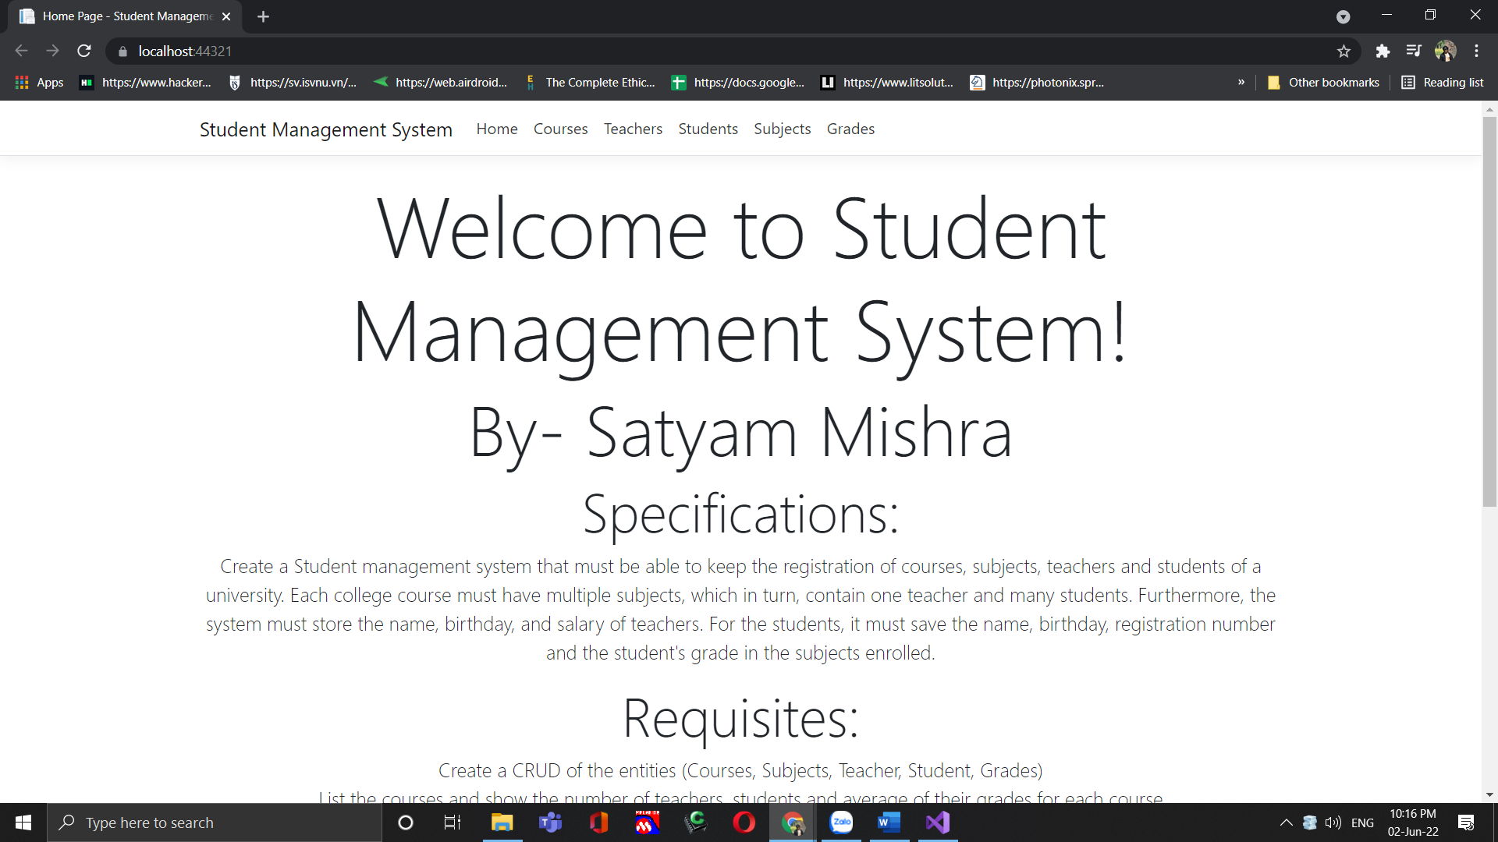
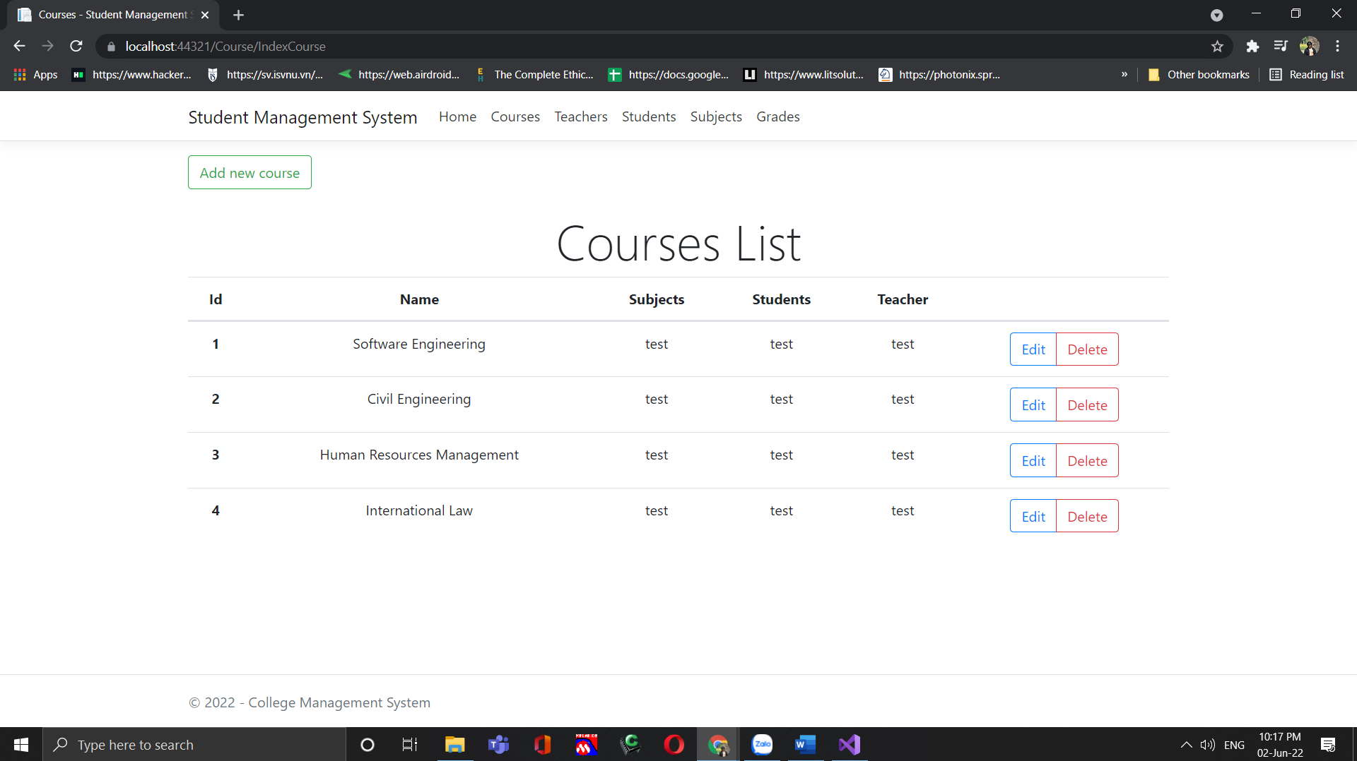
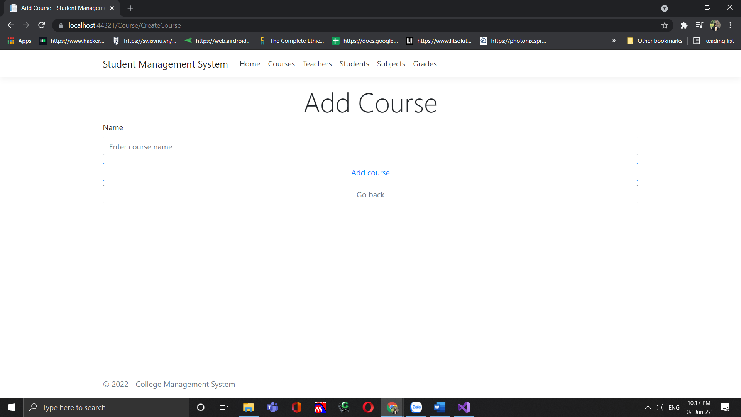
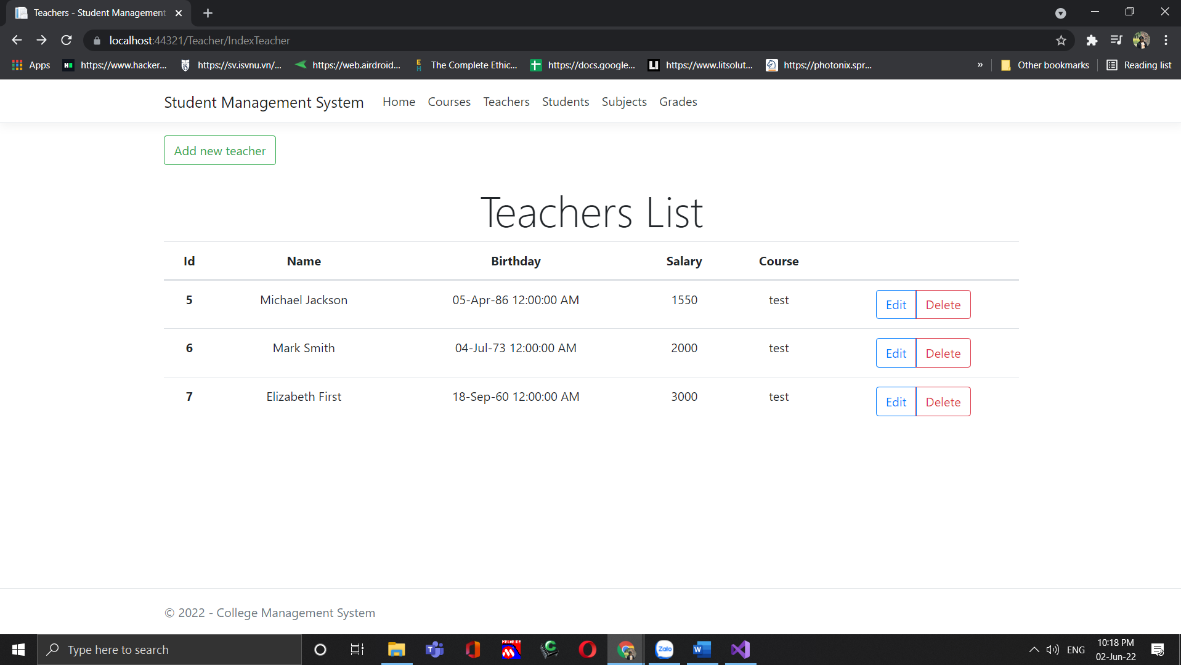
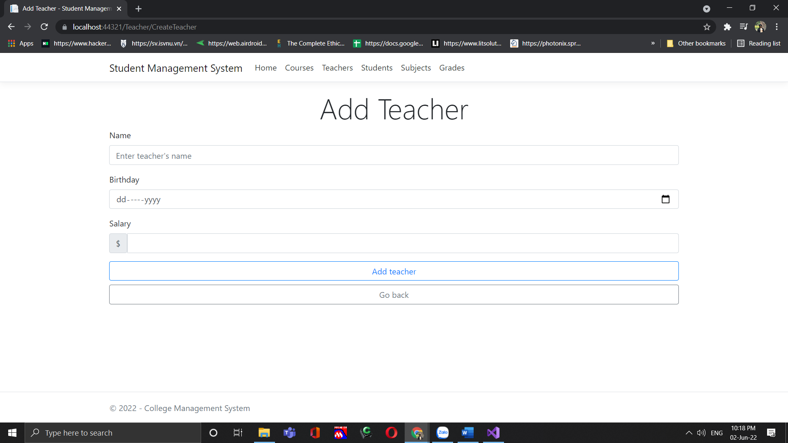
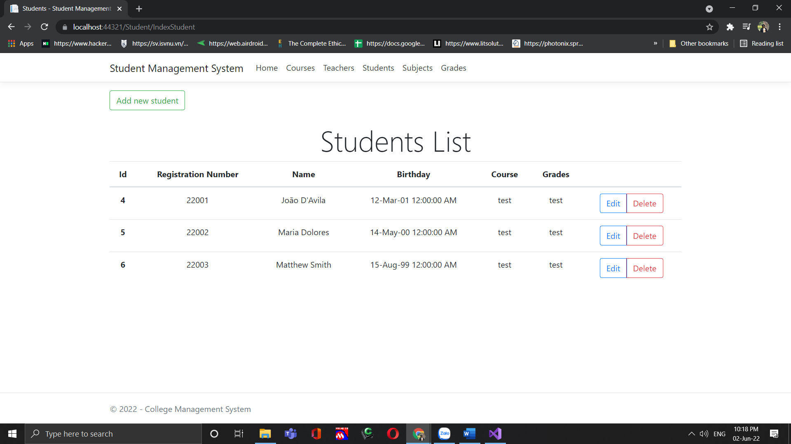

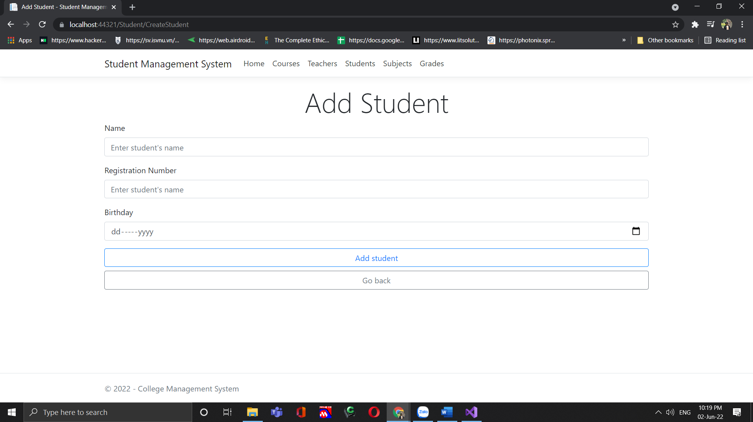
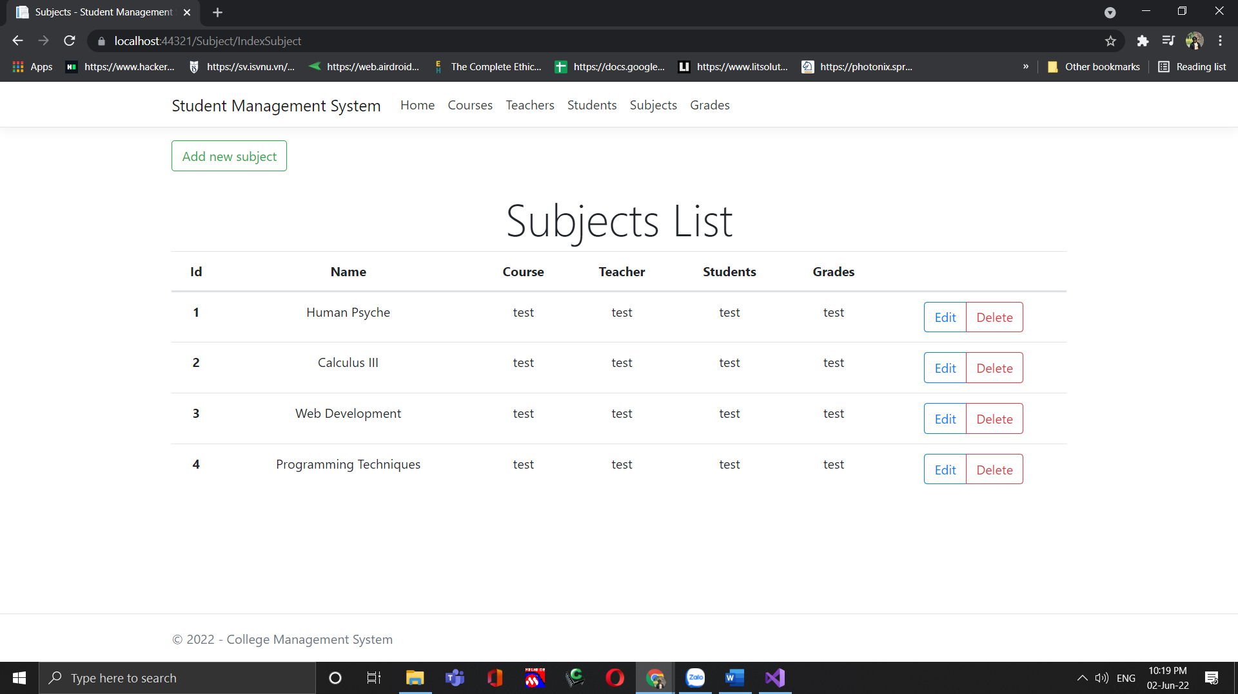
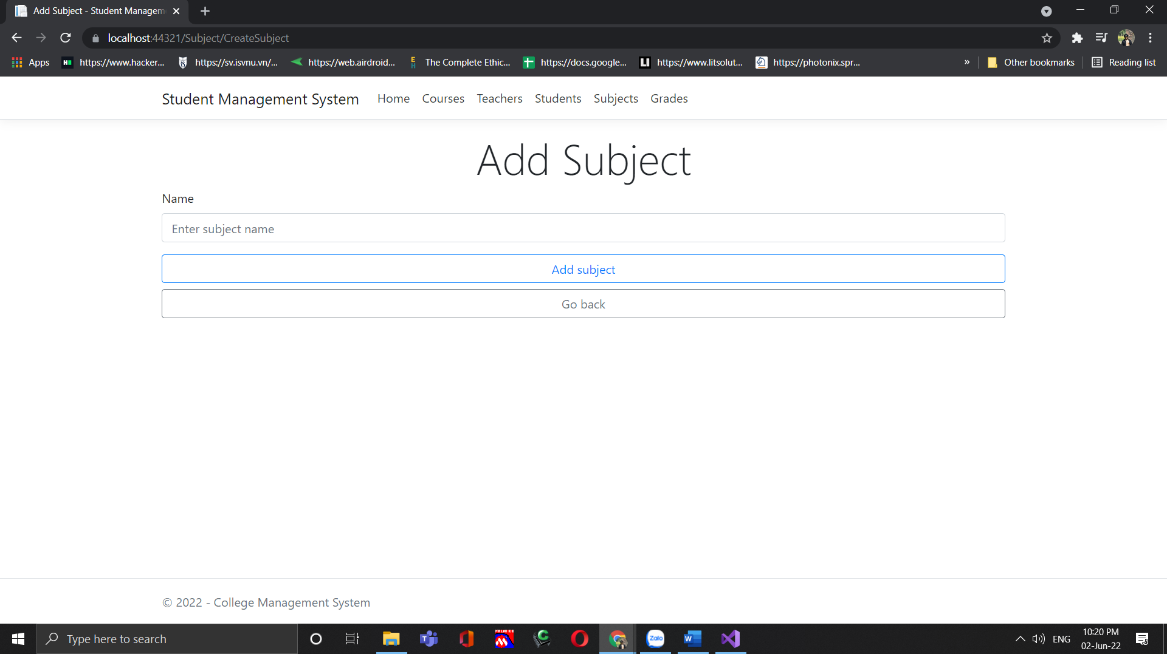
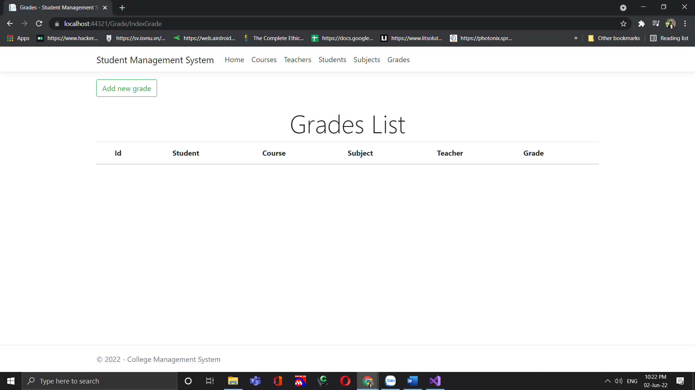

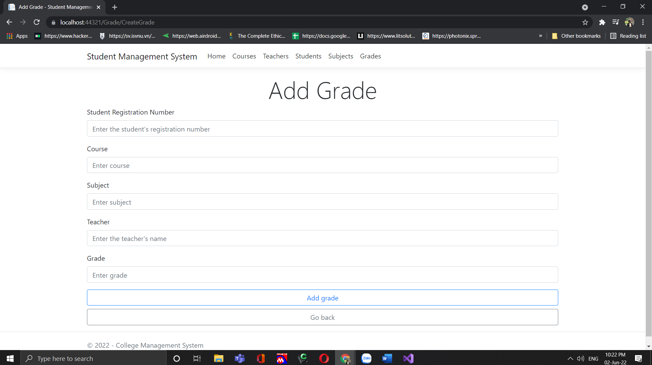

4.1.2 CLI
N/A
4.2 Hardware Interfaces
The app is designed for the Linux, macOS, Windows Console, Cloud, and web.
4.3 Communications Interfaces
The application will utilize the networking hardware of the user’s device through network communications services provided by the operating system. Network communications capability will be used to connect to remote databases and/or web services.
4.4 Software Interfaces
Non-additional

5. Performance Requirements
System
The application will run on all Linux, macOS, Windows Console, Cloud, and web. It will be around 50 mb in size. The application will respond to the size of the screen and/or window the application is running in.

Response Time
The application should take less than 4 seconds when running on any device. The application will run fine until the user begins to multi-task between 3 or more processes.

Scalability
The application will be able to scale to the size of the users as it increases.

6. Other non-functional attributes

6.1 Reliability
Most functionality will not require network connectivity.

6.2 Maintainability
The development team will follow best practices for clean code and software modularity to make the application as maintainable as possible.

6.3 Portability
Users can access it anytime through just one click.

6.4 Extensibility
The application will be highly extensible in terms of adding subject and student details or teachers. However, the application in general has low extensibility.

6.5 Reusability
An application instance shall be able to be reusable every semester for a returning student. The user will be able to update their classes by having the application check for a registered schedule set for the next semester and if the current school semester is over. Application components will be able to be integrated into the larger Student Management system and can be updated when needed as it is open source.

6.6 Application Affinity/Compatibility
The application shall be compatible with all Linux, macOS, Windows Console, Cloud, and web.

7. Preliminary Use Case Models and Sequence Diagrams

7.1 Use Case Model

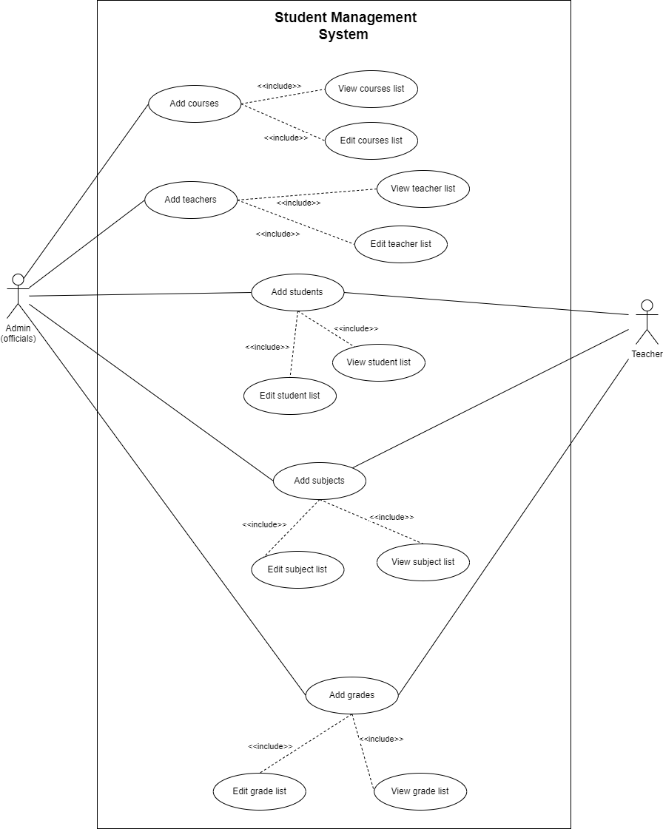

7.2 ER- Diagram

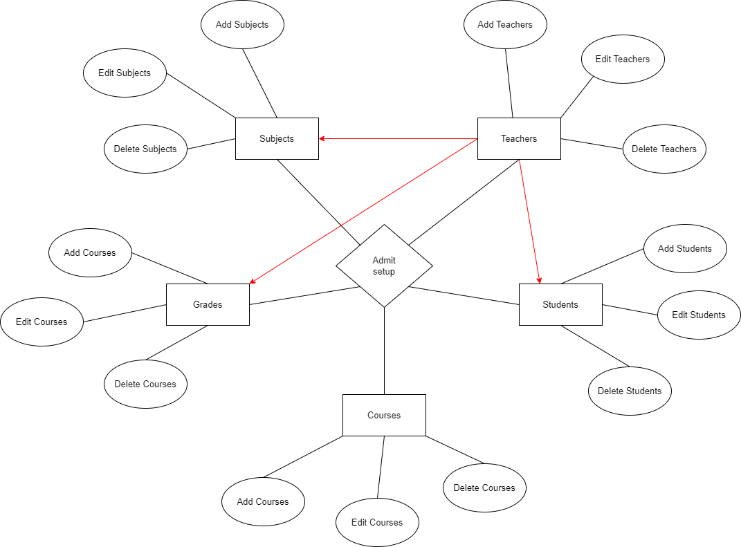

7.3 UML

